
RENEWABLE ENERGIES FOR MY COUNTRY
¨ Routes and Roads ¨
Renewables for my country is a project of ECR Solar, under the direction of the architect Enrique César Rodríguez. Tandil to Balcarce (1st stage). Them Balcarce to Mar del Plata (2nd stage) in the route 226 in Buenos Aires province, Argentina. Totaling some 180 km of solar lighting, establishing a pilot Tandil laying Mar del Plata (2 key tourist spots in the province of Buenos Aires), being the starting point for a future projection of routes and roads throughout Argentina.
Solar and wind street lamps for different regions of Argentina. Isolated streets, paths, roads and highways. The idea is to reach areas where power fails or is difficult to access. Suggested equipment cabinets and solar energy photovoltaic and areas favorable for wind power to the regions of Patagonia, where winds are excellent and optimum annual frequency.
ECR Solar experience in this type of installation is essential to carry out the project.

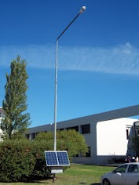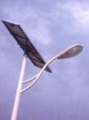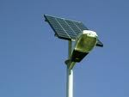
Solar Lanterns for routes and roads Argentine

